Week 12
Problem Statement:
A binary number is a combination of 1s and 0s. Its nth least significant digit is the nth digit
starting from the right starting with 1. Given a decimal number, convert it to binary and
determine the value of the the 4th least significant digit.
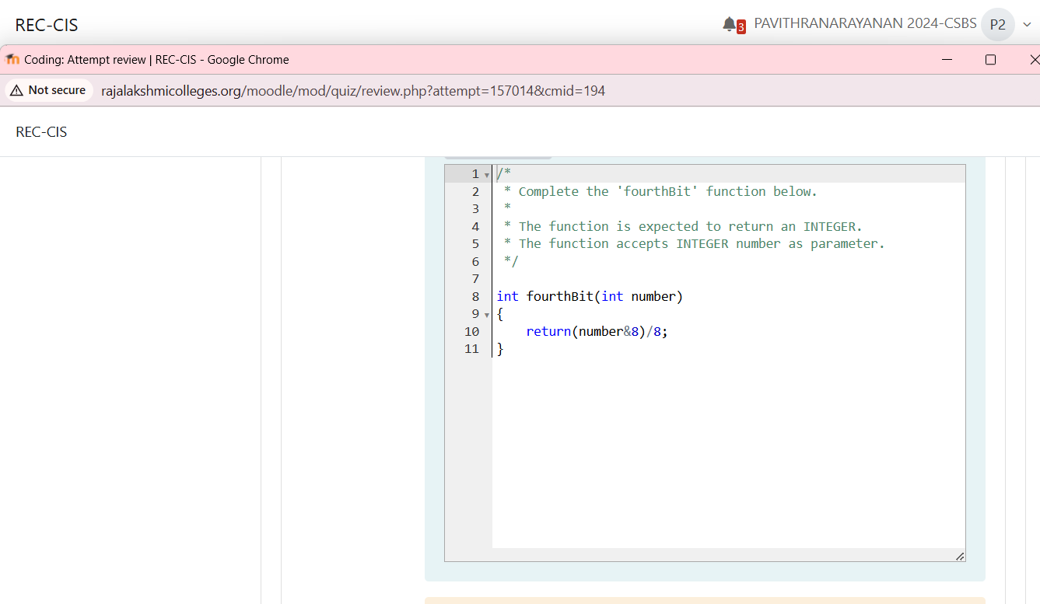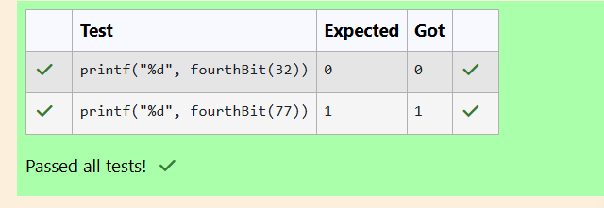
Problem Statement:
Determine the factors of a number (i.e., all positive integer values that evenly divide into
a number) and then return the pth element of the list, sorted ascending. If there is no pth
element, return 0.
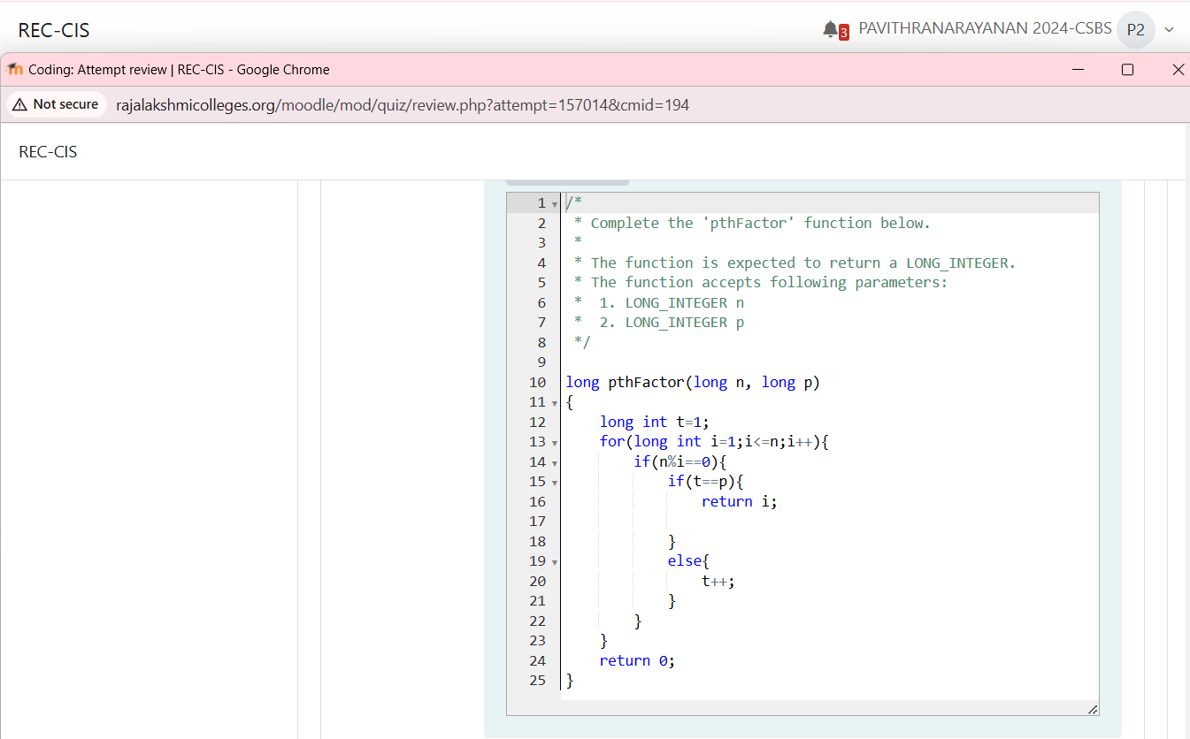
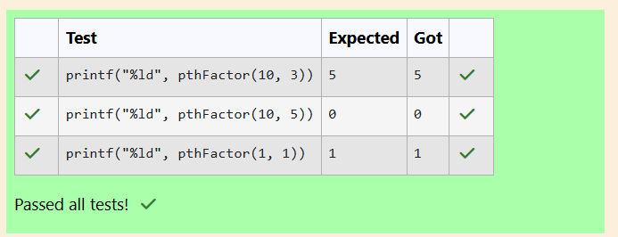
Problem Statement:
You are a bank account hacker. Initially you have 1 rupee in your account, and you want
exactly N rupees in your account. You wrote two hacks, first hack can multiply the amount
of money you own by 10, while the second can multiply it by 20. These hacks can be used
any number of time. Can you achieve the desired amount N using these hacks.

Constraints:
1<=T<=100
1<=N<=10^12

Input
• The test case contains a single integer N.

Output
For each test case, print a single line containing the string "1" if you can make exactly N
rupees or "0" otherwise.
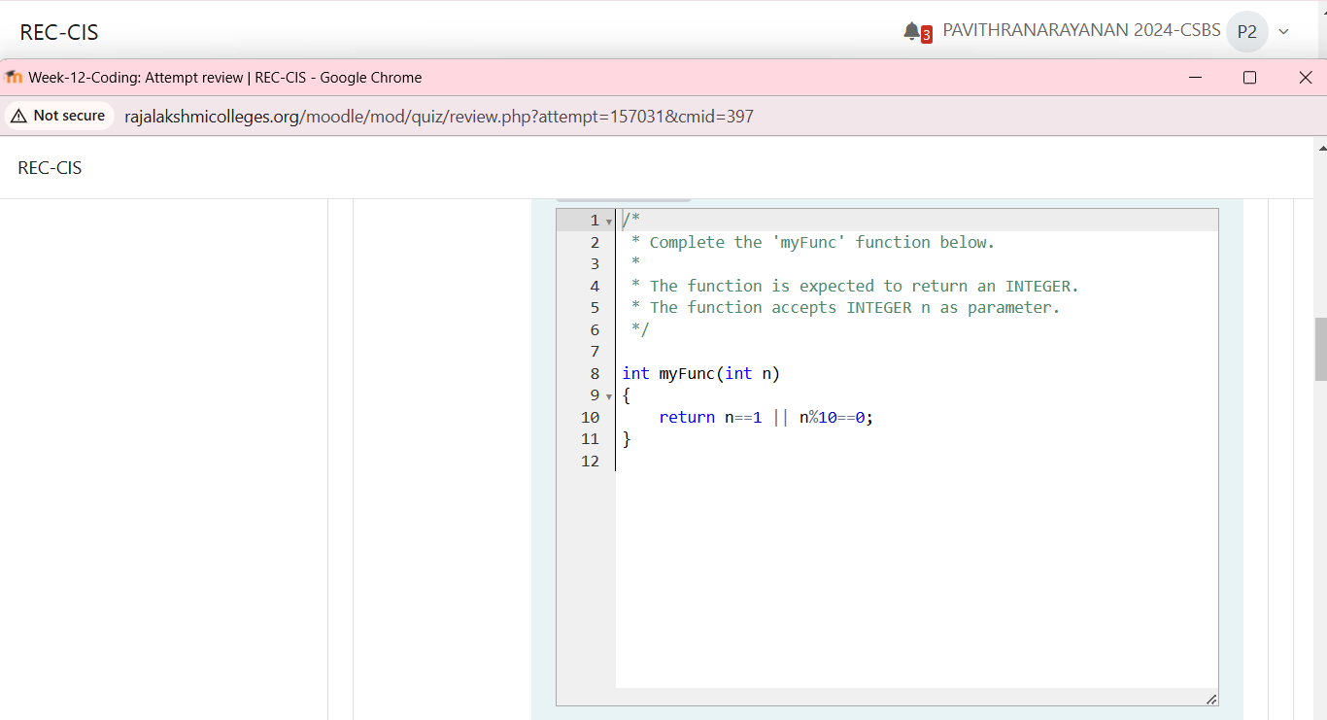
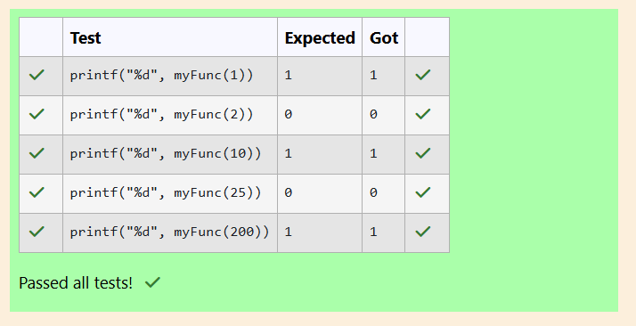
Problem Statement:
Find the number of ways that a given integer, X, can be expressed as the sum of the Nth
powers of unique, natural numbers.
For example, if X = 13 and N = 2, we have to find all combinations of unique squares adding
up to 13. The only solution is 22 + 32.
Function Description
Complete the powerSum function in the editor below. It should return an integer
that represents the number of possible combinations.
powerSum has the following parameter(s):
X: the integer to sum to
N: the integer power to raise numbers to
Input Format
The first line contains an integer X.
The second line contains an integer N.
Constraints
1 ≤ X ≤ 1000
2 ≤ N ≤ 10
Output Format
Output a single integer, the number of possible combinations calculated.
